AN IBEACON BASED AI-DRIVEN WEARABLE SUREVILLANCE SYSTEM FOR TRACKING AND INTERCEPTING FORCED HUMAN TRANSPORT

A Major-project Report submitted
in partial fulfilment for the award of the Degree of BACHELOR OF TECHNOLOGY
in
ELECTRONICS AND COMMUNICATION ENGINEERING
by

POLIPALLI RAJESH (U22EC348)

RAVULA VINAY KUMAR (U22EC367)

PULABALA SAI VARUN (U22EC361)

Under the guidance of

Ms. B. HEMALATHA.

ASSISTANT PROFESSOR/ECE


DEPARTMENT OF ELECTRONICS AND COMMUNICATION ENGINEERING SCHOOL OF ELECTRICAL SCIENCES
BHARATH INSTITUTE OF HIGHER EDUCATION AND RESEARCH

(Deemed to be University Estd u/s 3 of UGC Act, 1956)

CHENNAI 600073, TAMILNADU, INDIA

May 2026

BONAFIDE CERTIFICATE

This is to certify that this project entitled “AN IBEACON BASED AI-DRIVEN WEARABLE SUREVILLANCE SYSTEM FOR TRACKING AND INTRECEPTING FORCED HUMAN TRANSPORT” IS the Bonafide work of POLIPALLI RAJESH (U22EC348) , RAVULA VINAY KUMAR (U22EC367) , PULABALA SAI VARUN (U22EC361) who carried out the project work under our supervision . Certified further that to the best of knowledge the work reported here in does not form part of other thesis or dissertation on the basics of which a degree award conferred on an earlier occasion this or any other candidate.

SUPERVISOR HEAD OF THE DEPARTMENT
Dr. B. HEMALATHA. Dr. B. KALAISELVI
Assistant Professor Professor & Head
Department of ECE Department of ECE
BIHER BIHER
Chennai - 600073 Chennai - 600073

Submitted for the Project Viva-Voce examination held on ………………………

INTERNAL EXAMINER EXTERNAL EXAMINER

DECLARATION

We declare that this project report titled AN IBEACON BASED AI-DRIVEN WEARABLE SUREVILLANCE SYSTEM FOR TRACKING AND INTRECEPTING FORCED HUMAN TRANSPORT in partial fulfillment of the degree of B. Tech in (Electronics and communication Engineering) is a record of original work carried out by us under the supervision of Dr. B. HEMLATHA. (Associate Professor) and has not formed the basis for the award of any other degree or diploma, in this or any other Institution or University. In keeping with the ethical practice in reporting scientific information, due acknowledgements have been made wherever the findings of others have been cited.

POLIPALLI RAJESH (U22EC348)
RAVULA VINAY KUMAR (U22EC367)
PULABALA SAI VARUN (U22EC361)

ACKNOWLEDGMENT
We wish to thank the almighty who gave us good health and success throughout our project work. We express our deepest gratitude to our beloved President Dr. J. Sundeep Aanand, and Managing Director Dr. E. Swetha Sundeep Aanand for providing us the necessary facilities for the completion of our project. We wish to extend our thanks to Vice Chancellor (I/C) Dr. M. Sundararajan, Registrar Dr. S. Bhuminathan and Pro Vice Chancellor Dr. R. Hari Prakash and Dean (Academics) Dr. M. Sundara raj for backing us in this project. We thank our Dean, School of Electrical Sciences Dr. S. Prakash for his encouragement and the valuable Guidance .I am thankful to the Head of the Department Dr. B. Kalaiselvi and all staff members of the Department of Electronics & Communication Engineering, BIHER, for their encouragement and guidance throughout the course of the project period. I wish to express my sincere profound gratitude to my esteemed and endowed Project coordinator Dr. G. SUDHAGAR for inspiring us, healthy criticism, valuable suggestions and constant encouragement throughout the project period.
We also take the opportunity to express a deep sense of gratitude to our supervisor of
Dr. B. HEMALATHA for his cordial support, valuable information and guidance. She helped us completing this project through various states. We thank our department faculty, supporting staff and friends for their help and guidance to complete this project.

POLIPALLI RAJESH (U22EC348)
RAVULA VINAY KUMAR (U22EC367)
PULABALA SAI VARUN (U22EC361)

ABSTRACT

Human trafficking and forced human transport remain critical global challenges due to the absence of reliable real time victim detection mechanisms, especially in GPS denied and phone restricted environments such as vehicles, containers, and isolated transit routes. This project proposes an AI Driven Wearable Rescue Beacon System that automatically detects and signals potential forced transportation events using physiological and motion based intelligence. The system integrates a MAX30102 heart rate sensor, MEMS accelerometer, iBeacon BLE module, Wi-Fi connectivity, and an OLED based covert interface in a smartwatch form wearable. The wearable continuously learns the user’s normal activity patterns and physiological behavior. Using sensor fusion and anomaly detection models, it identifies abnormal stress responses, sudden movement patterns, sustained vehicular vibration signatures, and loss of familiar beacon environments to infer potential abduction scenarios. Upon detection, the device activates a silent rescue mode, broadcasting encrypted iBeacon distress identifiers while uploading compressed biometric and motion evidence to authorized receivers whenever connectivity is available. This approach enables victim detection without reliance on GPS or smartphones, functioning effectively in enclosed transport environments. By leveraging distributed BLE scanners at transit checkpoints such as toll booths, terminals, and patrol vehicles, the system allows real time interception of forced transport incidents. The proposed solution introduces a novel paradigm of intent based victim detection using wearable artificial intelligence, offering a scalable, privacy preserving, and lifesaving technology for combating human trafficking

TABLE OF CONTENTS

CHAPTER NO | TITLE | PAGE NO
1 | INTRODUCTION | 1
 | - Embedded System | 2
 | - Application of Embedded System | 3
 | 1.3 Types of Embedded System | 4
 | 1.4 Embedded System Network Applications | 5
2 | LITERATURE REVIEW | 6
3 | SYSTEM ANALYSIS | 7
 | 3.1 Existing System | 8
 | 3.2 Proposed System | 9 - 10
 | 3.3 Block Diagram | 11- 12
 | 3.4 Working Principle | 13
 | 3.5 Project Features | 14 - 15
4 | HARDWARE DESCRIPTION | 16 - 17
 | 4.1 ESP32 Controller | 18

 | 4.2 Device Features | 19 -20
 | 4.2.1 I/O Ports | 21 - 22
 | 4.2.2 Pin Output Drive | 23
 | 4.2.3 Input Pins And Voltage Considerations | 24 -26
 | 4.2.4 PORTA, TRISA AND LATA Registers | 27
 | 4.2.5 PORTB, TRISB AND LATB Registers | 28 - 29
 | 4.2.6 PORTC, TRISC AND LATC Registers | 30
 | 4.2.7 PORTD, TRISD AND LATD Registers | 31
 | 4.2.8 PORTE, TRISE AND LATE Registers | 32
 | 4.3 Memory Unit | 33
 | 4.4 Central Processing Unit | 34 -35
 | 4.5 Input-Output Unit | 36
 | 4.6 Serial Communication | 37
 | 4.7 Timer Unit | 38
 | 4.8 Analog To Digital Converter | 39
 | 4.9 CISC And RISC | 40
 | 4.10 Memory Organization | 41
 | 4.10.1 Program Memory Organization | 42
 | 4.10.2 Data Memory Organization | 43
 | 4.10.3 General Purpose Register File | 44 - 45
 | 4.10.4 Special Function Registers | 46

 | 4.10.5 Status Register | 47
 | 4.11 I2C Protocol | 48
 | 4.12. Display Unit | 49 – 50
 | 4.13 GSM Modem | 51
 | 4.14 Power Supply | 52 - 53
 | 4.15 GPS Modem | 54
 | 4.16 Push Key | 55 - 56
 | 4.17 Heartbeat Sensor | 57
 | 4.18 MEMS Detector | 58 - 59
5 | SOFTWARE DESCRIPTION | 60
 | 5.1 Introduction | 61 - 62
 | 5.2 Mplab IDE | 63
 | 5.3 C18 Compiler | 64 - 65
6 | CONCLUSION AND FUTRE SCOPE | 66
 | REFERENCES | 67 - 75

CHAPTER 1
INTRODUCTION

In today’s world, women safety has become a major issue as they can’t step out of their house at any given time due to physical/sexual abuse and a fear of violence. Even in the 21st century where the technology is rapidly growing and new gadgets were developed but still women’s and girls are facing problems. Women are adapt at mobilizing diverse groups for a common reason. They often work across ethnic, religious, political, and cultural divides to promote liberty. We are all aware of importance of women safety, but we must analyze that they should be properly protected. Women are not as physically fit as men, in an emergency situation a helping hand would be assistance for them. The best way to cur tail your probability of becoming a dupe of violent crime (robbery, sexual assault, rape, domestic violence) is to recognize, defence and look up resources to help you out of hazardous situation. If you're in dilemma or get split from friends during a night out and don't know how to find back residence, this device with you will guard you and can reduce your risk and bring assistance when you need it. There are several app reduce the risk of sexual assault on women by informing control centre and their associates through SMS, but inlay of those this apparatus have much more efficient way to inform those this respected personals and also has a defending system which cannot be provided by existing app. This paper focuses on a security system that is designed solely to serve the purpose of providing security to women so that they never feel helpless while facing such social challenges. The system resembles a normal cloves which when activated, tracks the location of the victim using GPS (Global Positioning System) and sends emergency messages using GSM (Global System for Mobile communication), to three emergency contacts and the police control room. The system also incorporates a screaming alarm that uses real-time clock, to call out for help and also generates an electric shock to injure the attacker for self defence.

1.1 EMBEDDED SYSTEM:
A general definition of embedded systems is: embedded systems are computing systems with tightly coupled hardware and software integration, which are designed to perform a dedicated function. In some cases, embedded systems can function as standalone systems One class of embedded processors focuses on size, power consumption, and price. Therefore, some embedded processors are limited in functionality, i.e., a processor is good enough for the class of applications for which it was designed but is likely inadequate for other classes of applications.
Real-time systems are defined as those systems in which the overall correctness of the system depends on both the functional correctness and the timing correctness. The timing correctness is at least as important as the functional correctness.
1.2 APPLICATION OF EMBEDDED SYSTEM
In real life we are using so many embedded systems for example Home application (micro oven, washing machine, security system DVD, Mp3 player etc,) Air craft, missiles, automotive, nuclear research, personal use (mobile phone, I pod)
1.3 TYPES OF EMBEDDED SYSTEM
Embedded System is broadly categorized as
Standalone embedded system
Example: Washing Machine,
Networking embedded system
Example: Network Printer

1.4 EMBEDDED SYSTEM NETWORK APPLICATIONS.
Embedded systems are designed to do some specific task, rather than be a general-purpose computer for multiple tasks. Some also have real-time performance constraints that must be met, for reason such as safety and usability; others may have low or no performance requirements, allowing the system hardware to be simplified to reduce costs.
Embedded systems are not always separate devices. Most often they are physically built-in to the devices they control.
The software written for embedded systems is often called firmware, and is stored in read-only memory or Flash memory chips rather than a disk drive. It often runs with limited computer hardware resources: small or no keyboard, screen, and little memory.
Embedded System Design and Development Life Cycle
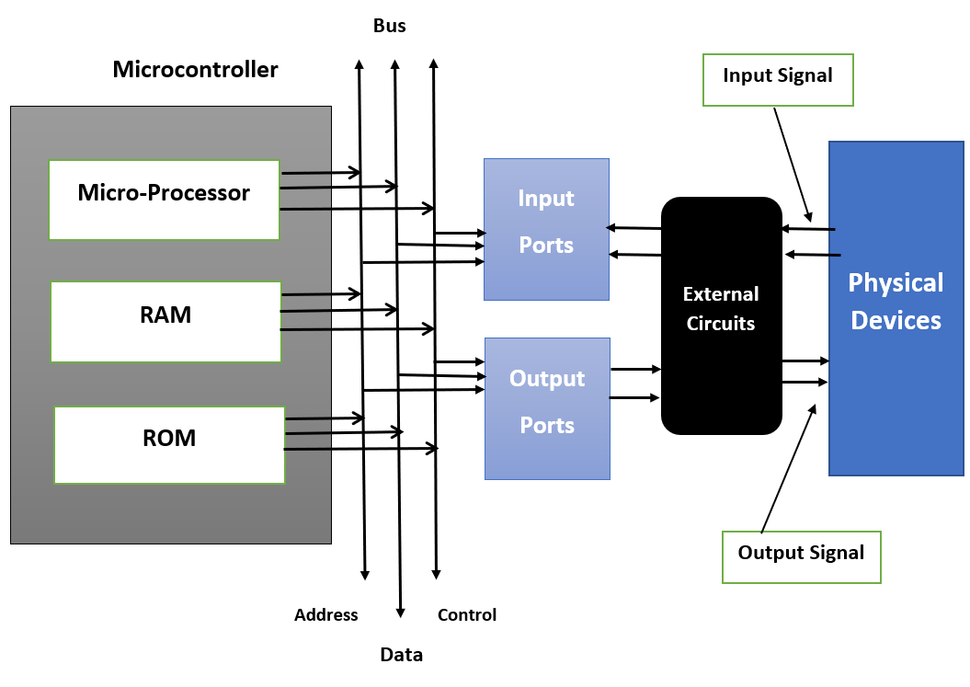
Figure 1.1: Embedded System Design

CHAPTER 2
LITERATURE SURVEY

2.1 A smart watch for women security based on Iot concept ‘watch me’ A. Helen ; M. Fathima Fathila ; R. Rijwana ; Kalaiselvi V.K.G. IEEE 2025.
Today, in the current global scenario, Women were facing lot of challenges. We can hear the news of women harassments than their achievements. There are many existing apps and devices for women security via smart phones. Though the smart phones have increased rapidly, it is not possible to have the phone all the time in our hand to make a call or click on it, so here we introduced a new technique via smart watches. When a women or child wearing this `watch me' is exposed to sexual or vulnerable attack, the sensor present in it detects the heart beat rate of a person which will be high at the moment by the secretion of epinephrine hormone from hpa axis and gets activated, this will not only provide a alarm sound to the attention of nearby people, it will automatically make an call to our registered contact and also through GPS/GSM it will detect the nearby police station and make an ring there so it will be helpful for police to arrive soon at the spot by tracking the GPS, such a system will lead to safer and better environment.

2.2 Design of a modular real time smart accessory Adil A Kumar ; P Sree Sai Sharan ; Mohamed Rehan ; B. N. Chandra Shekar ; Rajeshwari Hegde IEEE 2025.
The use of smart devices has increased exponentially in the last few years. In this background, we predict a bright future for smart accessories like smart watches. A number of smart watches have been developed with different focus areas and objectives. The aim of this paper is the design of a modular smart accessory with focus on day to day routine functionality as well as incorporating safety features that could aid women and children
safety. The idea of modularity is to demonstrate that only a set of features could be used based on the end user. This paper focuses on the design and implementation of a fully functioning prototype of a modular real time smart accessory which interacts with a
smart phone via Bluetooth and has add-on features like heart rate monitoring, accelerometer and GSM capability. This paper explains the need for a modular smart accessory in the current day. The system architecture that was involved in this prototype is discussed in detail. The overall implementation method as well as merits of the used approach has been discussed.

2.3 IoT Based Smart Security Gadget for Women’s Safety Tejonidhi M. R ; Aishwarya ; Chaithra K. S ; Dayana M. K ; Nagamma H IEEE 2025.
Nowadays, personal safety has become a significant problem for everyone, but especially for women. A recent survey made by WHO indicates 35 percent of women, globally, facing some form of abuse and physical violence. The count of victim is gradually increasing. Here we introduce a system which makes sure the women protection. The device can be easily carried and could be taken whenever they sense the danger. The project idea is to provide a swift responding and reporting safety device for women. The application helps women to overcome with fear and can call to her guardian that she can take the help. It reports a situation just by pressing button on the smart band. Our project resembles a smart band; it has the capability to protect the women, with the various sensors integrated within the band. When she wearing the band or a watch, if she face any Kind of harassment or if she feel something happened to be endanger she can press the button located on the watch, when she fall in down, the various information such as location, body posture, pulse rate and SMS alert are sent to the predefined number by using the GSM through Raspberry Pi. We can get the exact location of the victim by using the GPS it sends the longitude and latitude of the victim so that, police can easily find the victim and the incident can be easily avoided and can save the women, punish the culprit. Using the IoT platform one we can track the information of the women remotely. This will help to reduce the crime against the women.

2.4 Securing the Network for a Smart Bracelet System Iuliana Marin ; Nicolae Goga IEEE 2025.
Digital instruments play a vital role in our daily life. It is a routine to produce business papers, watch the news program, write articles and blogs, manage healthcare systems, to purchase online, to send messages and all this is processed by making observations and
then manipulating, receiving and availing the diverse data. This electronic data provides the foundation of real time data. All this transmission of data needs to be secured. Security is essential for healthcare systems as the present one where the blood pressure recordings provided by the smart bracelet are sent to the user's mobile phone via Bluetooth. The bracelet monitors the pregnant women, but also other users who wish to have their blood pressure under control. The system's server analyses the recordings and announces the user, as well as the associated persons to the user in case of an emergency. The doctors, the medical staff, user and user's family and caregivers have access to the health recordings belonging to the monitored user. Security is a main feature of the electronic healthcare system based on the smart bracelet.

2.5 Survey on Womens safety mobile app development R. Pavitra ; S. Karthikeyan IEEE 2025.
Presently mobile application advancement assumes a significant part with working frameworks like Windows, Android, and IOS etc. This portable application is fundamentally utilized for women's wellbeing. It can be utilized to discover and help women's in crisis circumstance. It demonstrates the correct area where the individual is found and send the point of interest through Short Message Service (SMS) to her relatives, guardian and friends. In this paper, review has been done on portable application and furthermore talked about different disadvantages.

2.6 Foot Device for Women Security S. A. Bankar ; Kedar Basatwar ; Priti Divekar ; Parbani Sinha ; Harsh Gupta IEEE 2025.
Women are facing many security problems nowadays. In such cases, she feels handicapped and need help to protect herself. Hence there must be a smart device which can protect her in such difficult situations. Here we introduce a smart device which ensures the protection of women. This smart device will be clipped to the footwear of a woman and can be triggered discreetly on tapping her feet 10 or more times within 5 seconds or with one touch switch system. Along with this unnatural rise or fall of her heartbeat will also be sensed and the values of the same will be displayed on the `Women Security' mobile application which is developed by us and installed in her smart phone. Simultaneously audio recording feature in the application will record the incident that can
be used later as a proof if required. At the same time, a buzzer gets sounded which would make the surroundings alert and she can get immediate help. For her self-defence, there is a knife attached to the device.

2.7 IoT based monitoring of foot pressure using FSR sensor Payal S. Malvade ; Atul K. Joshi ; Swati P. Madhe IEEE 2025.
Analysis of foot plantar pressure distribution is an important factor considered today in the field of healthcare as well as in sports world. Lower body physical rehabilitation therapies are associated with sports world. To avoid long-term damage to the affected part and to accelerate the recovery period, it is necessary to keep an eye on the patient regularly following his/her rehabilitation activities not only in the hospital but also at home. Multiple techniques have been developed for quantitative gait analysis but comparatively these systematic process fails as it measures static or dynamic process for very short duration of time and space. In the proposed system, an electronic insole system is designed in a shoe using force sensing resistor (FSR) sensor that monitors pressure wirelessly, thus saving the information in an array of sensor network for transferring data into CPU. Thus considering the information available used for further study purpose. Four sensors are placed, one at the heel, one at the lateral part, one at the metatarsal head and one at the anterior. The plantar pressure is used to analyse pressure distribution. The signal from the pressure sensor will be processed by microcontroller and sent to mobile via Bluetooth module. With the help of Internet-of-Things (IoT), when the signal goes beyond the limit the notification will be sent to patient consulting the doctors/physiotherapist so that immediate action can be carried out further. The proposed system will help the doctors/physiotherapist as well as person to monitor his health using smart shoe. The device can help the clinician and the patient a tool to monitor and receive condition feedback.
2.8 Analysis of Women Safety in Indian Cities Using Machine Learning on Tweets Deepak Kumar ; Shivani Aggarwal IEEE 2025.
Women and girls have been experiencing a lot of violence and harassment in public places in various cities starting from stalking and leading to sexual harassment or sexual assault. This research paper basically focuses on the role of social media in promoting the
safety of women in Indian cities with special reference to the role of social media websites and applications including Twitter platform Facebook and Instagram. This paper also focuses on how a sense of responsibility on part of Indian society can be developed the common Indian people so that we should focus on the safety of women surrounding them. Tweets on Twitter which usually contains images and text and also written messages and quotes which focus on the safety of women in Indian cities can be used to read a message amongst the Indian Youth Culture and educate people to take strict action and punish those who harass the women. Twitter and other Twitter handles which include hash tag messages that are widely spread across the whole globe sir as a platform for women to express their views about how they feel while we go out for work or travel in a public transport and what is the state of their mind when they are surrounded by unknown men and whether these women feel safe or not?

2.9 Smart Shoe for Women Safety Vishesh Sharma ; Yati Tomar ; D. Vydeki IEEE 2025.
The world needs to be concerned about the women around and treat them the way they deserve to be treated. Despite having so many laws for women, it doesn't stop thieves, assaulters or molesters to abuse women. This paper suggests a smart shoe that not only helps women take care of themselves but also help them be fearless. This project makes use of GPS, GSM modules, a shock circuit and camera, that are interfaced with Raspberry Pi board and Arduino. Women facing any troubles or in any kind of danger, can immediately make use of this device, embedded in their shoe to escape from the dangerous situation and even harm the attacker.

2.10 Safety Assistant And Harassment Prevention For Women Md. Raseduzzaman Ruman ; Joybrota Kumar Badhon ; Saikat Saha IEEE 2025.
Nowadays we have seen many women, young girls and mothers disappearing and facing physical and sexual harassment from public places, streets and public transport. Many cases are being filed on a regular basis on issues such as kidnapping, harassments or assaults and these crimes are increasing day by day. In order to stop these crimes, we
designed an embedded system for women safety based on Arduino and GSM module with GPS to send an emergency message with location and generate an alarm. This

In today’s modern world, women’s safety has become one of the most important social concerns. Even though technology and security systems have improved significantly, many women still face unsafe situations while traveling, working, studying, or moving alone in public places. To address this issue, the research paper titled “Smart Shoe for Women Safety” proposes an innovative wearable safety device designed in the form of a smart shoe. The main objective of this system is to provide immediate protection, emergency communication, and location tracking during dangerous situations.
The paper explains that traditional safety methods are often not enough during emergencies because victims may not have enough time to use mobile phones or manually contact others. Therefore, the researchers designed a wearable system that can quickly respond during distress situations without depending completely on smartphones. The smart shoe acts as a hidden and portable safety device that can easily be carried and used in everyday life

The proposed smart shoe integrates several advanced technologies such as:
- GPS (Global Positioning System)
- GSM (Global System for Mobile Communication)
- Sensors
- Camera module
- Microcontroller-based control system
The GPS module is used to identify the real-time location of the user. During emergency situations, the system can automatically send the user’s location to family members, police, or emergency contacts. This helps rescuers quickly identify the victim’s location and provide immediate assistance.
The GSM module is responsible for sending alert messages and emergency notifications. When the user activates the safety mechanism, the device transmits distress messages through the mobile communication network. This ensures that emergency information reaches the concerned persons without delay.
One of the unique features discussed in this paper is the inclusion of a self-defense shock mechanism. The smart shoe is designed with a small electric shock circuit that can temporarily disable or distract attackers, allowing the victim to escape from dangerous situations. This feature increases personal safety and provides an additional layer of protection during physical attacks.

The system also includes a camera module that captures images or video evidence during emergency situations. This evidence can help authorities identify criminals and support legal investigations later. The researchers emphasize that collecting evidence automatically can improve the effectiveness of security systems and help prevent crimes.
The entire system is controlled using a microcontroller platform such as Arduino or Raspberry Pi. The controller manages sensor inputs, communication modules, emergency alerts, and other system operations. The device is designed to be lightweight, portable, energy-efficient, and easy to use.
The paper highlights the importance of wearable safety technology because wearable devices remain close to the user at all times and can provide faster responses during emergencies compared to mobile applications alone. Since the device is integrated into footwear, it remains hidden and less noticeable, making it practical for everyday usage.
This research is highly relevant to modern smart safety systems because it combines communication technology, sensors, location tracking, and emergency response into a single wearable platform. The proposed solution aims to increase women’s confidence and provide safer mobility in public and isolated areas.

This reference is strongly related to your project because both systems focus on:
- Wearable safety devices
- Emergency detection systems
- Smart monitoring technologies
- Personal security applications
- Sensor-based safety monitoring
- Fast emergency communication

The system sends a message to the police control room, family and friends. It's also track the location to ensure safety for women. This also comes with an additional feature consisting of a shock generator for self-defense of women in an intense situation. When the victim will be in danger, it also generate an emergency call which will be activated by the victim. This wireless device is convenient and can be activated by the victim on being harassed just by the click of a push button. The performance of this device showed an overall accuracy of 92.6%. The main purpose is to ensure public safety in the emergency situation.

CHAPTER 3
SYSTEM ANALYSIS

3.1 EXISTING SYSTEM
Touch Sensor The module is built on touching- sensing IC TTP223B.In the idle state, the module output remains at 0(low0). If the finger is touched on the corresponding position the module output goes high(1).If it is not touched for 12 seconds, it switches to low power mode. This Module can be mounted on glass, plastic or non-metallic materials. Touch sensor, different mechanical devices, do not contain moving parts. Hence, they are the more long-lasting devices than mechanical input devices. Touch sensor are robust as there are no opening for humidity and dust to enter. Piezo Buzzer Based on contra of the piezoelectric effect the sound is produced by the piezo buzzer. The main principle of the piezo buzzer is the generation of pressure variation which is based on the application of electrical potential across the piezoelectric. The buzzer can also be used in the alarm circuits etc.

Existing System Disadvantages:
- Human trafficking detection mainly relies on CCTV and manual monitoring, which is ineffective in enclosed vehicles or isolated environments.
- GPS tracking fails in indoor, underground, or metal-enclosed transport areas, leaving victims untraceable.
- Emergency alert systems require manual activation, which is impossible if the victim is restrained or incapacitated.
- Current solutions do not integrate physiological stress signals or abnormal motion detection to identify forced transport.
- Existing iBeacon systems lack intelligence, secure distress broadcasting, and real-time victim detection capabilities.

  - PROPOSED SYSTEM

The basic principle used for security system is prevention and communication by Using GPS, GSM technology. It consists of Arduino, Touch sensor, Buzzer, GPS and GSM technology. Arduino UNO is used to control the overall process. The Arduino is programmed by mean of C languages and then compiled and stored in the flash memory. It has everything needed to support the microcontroller; simply connect it to a computer with a battery to get started it with an AC-to-DC adapter. The user can tinker with the UNO without concerned more around doing something bad, worst case scenario you can replace the chip and start over again.

The touch-sensing IC TTP223B is built by capacitive touch sensor. In the groundless state, the output of the module remains at 0(low0). When the finger is touched on the sensor, the output of the module goes high (1).If the finger is not touched for 12 seconds, switches to low- power mode. Module can be installed on ductile, reflector or non-metallic material. When a potential is applied across these crystals, they pull on one conductor and push on the other. This push and pull action, results in a second wave. KHz More buzzer produce sound in the range of 2-4KHz. A GSM module is basically a GSM modem (like SIM 900) Connected to a PCB with different type of output taken from the board – say TTL output (for the Arduino controller 8051 and other contollers) and provisions.

GPS Module continuously receives the data from the satellite and transmit correspondingly to the RS232. The antenna input module receive the GPS signals and complete serial data message with position, velocity, and time information is presented at the serial line. The current date, time, longitude, latitude, altitude, speed, and travel direction among data, are provided by the module and can be used in many application including Navigation system, fleet management system, tracking, mapping and robotics.

GPS will track the user location and send information to emergency contacts by touching the sensor. At the same time irritating gas which is called tear gas is released from the device. It will cause severe eye irritation to the stranger. Thus the victim can have the enough time to escape from the stranger at the time of facing a strange situation. The buzzer will intimate the people for help by using alarming sounds. The GPS and GSM technology will send information to controller of police and neighbors. We also use Emergency switch, heart beat and sound detector sensor so any one senses SMS will be sent to the concern person.

Proposed System Advantages:
- AI-driven wearable smartwatch integrates heart rate (MAX30102), MEMS accelerometer, and iBeacon BLE to monitor physiological and motion patterns continuously.
- Learns the user’s normal activity and stress levels to detect abnormal patterns indicative of forced transport.
- Automatically triggers silent rescue mode upon detecting potential abduction, without requiring manual activation.
- Broadcasts encrypted iBeacon distress signals and uploads motion + biometric data to authorized receivers when network is available.
- Enables real-time interception through BLE scanners at transit checkpoints, terminals, and patrol vehicles, ensuring covert victim protection even in GPS-denied environments.

3.3 BLOCK DIAGRAM

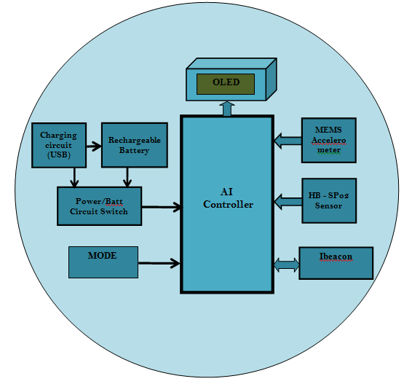
3.4 PROJECT FEATURES
1. Low cost.
2. High speed networking.
3. Low power consumption.
4. Light weight network
5. Broadcast communication

CHAPTER 4
HARDWARE DESCRIPTION

4.1 ESP32 MICROCONTROLLER
The ESP32 is a microcontroller board based on the ATmega328 (datasheet). It has 14 digital input/output pins (of which 6 can be used as PWM outputs), 6 analog inputs, a 16 MHz ceramic resonator, a USB connection, a power jack, an ICSP header, and a reset button. It contains everything needed to support the microcontroller; simply connect it to a computer with a USB cable or power it with a AC-to-DC adapter or battery to get started.

The Uno differs from all preceding boards in that it does not use the FTDI USB-to-serial driver chip. Instead, it features the Atmega16U2 (Atmega8U2 up to version R2) programmed as a USB-to-serial converter.

Revision 2 of the Uno board has a resistor pulling the 8U2 HWB line to ground, making it easier to put into DFU mode.
Revision 3 of the board has the following new features:

- pinout: added SDA and SCL pins that are near to the AREF pin and two other new pins placed near to the RESET pin, the IOREF that allow the shields to adapt to the voltage provided from the board. In future, shields will be compatible both with the board that use the AVR, which operate with 5V and with the Arduino Due that operate with 3.3V. The second one is a not connected pin, that is reserved for future purposes.

- Stronger RESET circuit.

- Atmega 16U2 replace the 8U2.

"Uno" means one in Italian and is named to mark the upcoming release of Arduino 1.0. The Uno and version 1.0 will be the reference versions of Arduino, moving forward. The Uno is the latest in a series of USB Arduino boards, and the reference model for the Arduino platform; for a comparison with previous versions, see the index of Arduino boards.

Summary

Microcontroller ATmega328
Operating Voltage 5V
Input Voltage (recommended) 7-12V
Digital I/O Pins | 14 | (of which 6 provide PWM output)
Analog Input Pins | 6
DC Current per I/O Pin | 40 mA
DC Current for 3.3V Pin | 50 Ma
Flash Memory | 32 | KB (ATmega328)
SRAM | 2 KB (ATmega328)
EEPROM | 1 KB (ATmega328)
Clock Speed | 16 | MHz

Schematic & Reference Design
EAGLE files: arduino-uno-Rev3-reference-design.zip (NOTE: works with Eagle 6.0 and newer) Schematic: arduino-uno-Rev3-schematic.pdf

Note: The Arduino reference design can use an Atmega8, 168, or 328, Current models use an ATmega328, but an Atmega8 is shown in the schematic for reference. The pin configuration is identical on all three processors.

Power

The Arduino Uno can be powered via the USB connection or with an external power supply. The power source is selected automatically.

External (non-USB) power can come either from an AC-to-DC adapter (wall-wart) or battery. The adapter can be connected by plugging a 2.1mm center-positive plug into the board's power jack. Leads from a battery can be inserted in the Gnd and Vin pin headers of the POWER connector.

The board can operate on an external supply of 6 to 20 volts. If supplied with less than 7V, however, the 5V pin may supply less than five volts and the board may be unstable. If using more than 12V, the voltage regulator may overheat and damage the board. The recommended range is 7 to 12 volts.

The power pins are as follows:

- VIN. The input voltage to the Arduino board when it's using an external power source (as opposed to 5 volts from the USB connection or other regulated power source). You can supply voltage through this pin, or, if supplying voltage via the power jack, access it through this pin.

- 5V.This pin outputs a regulated 5V from the regulator on the board. The board can be supplied with power either from the DC power jack (7 - 12V), the USB connector (5V), or the VIN pin of the board (7-12V). Supplying voltage via the 5V or 3.3V pins bypasses the regulator, and can damage your board. We don't advise it.

- 3V3. A 3.3 volt supply generated by the on-board regulator. Maximum current draw is 50 mA.
- GND. Ground pins.

Memory

The ATmega328 has 32 KB (with 0.5 KB used for the bootloader). It also has 2 KB of SRAM and 1 KB of EEPROM (which can be read and written with the EEPROM library).

Input and Output

Each of the 14 digital pins on the Uno can be used as an input or output, using pinMode(), digitalWrite(), and digitalRead() functions. They operate at 5 volts. Each pin can provide or receive a maximum of 40 mA and has an internal pull-up resistor (disconnected by default) of 20-50 kOhms. In addition, some pins have specialized functions:

- Serial: 0 (RX) and 1 (TX). Used to receive (RX) and transmit (TX) TTL serial data. These pins are connected to the corresponding pins of the ATmega8U2 USB-to-TTL Serial chip.

- External Interrupts: 2 and 3. These pins can be configured to trigger an interrupt on a low value, a rising or falling edge, or a change in value. See the attachInterrupt() function for details.

- PWM: 3, 5, 6, 9, 10, and 11. Provide 8-bit PWM output with the analogWrite() function.

- SPI: 10 (SS), 11 (MOSI), 12 (MISO), 13 (SCK). These pins support SPI communication using the SPI library.

- LED: 13. There is a built-in LED connected to digital pin 13. When the pin is HIGH value, the LED is on, when the pin is LOW, it's off.

The Uno has 6 analog inputs, labeled A0 through A5, each of which provide 10 bits of resolution (i.e. 1024 different values). By default they measure from ground to 5 volts, though is it possible to change the upper end of their range using the AREF pin and the analogReference() function. Additionally, some pins have specialized functionality:

- TWI: A4 or SDA pin and A5 or SCL pin. Support TWI communication using the Wire library. There are a couple of other pins on the board:

- AREF. Reference voltage for the analog inputs. Used with analogReference().

- Reset. Bring this line LOW to reset the microcontroller. Typically used to add a reset button to shields which block the one on the board.

See also the mapping between Arduino pins and ATmega328 ports. The mapping for the Atmega8, 168, and 328 is identical.

Communication

The Arduino Uno has a number of facilities for communicating with a computer, another Arduino, or other microcontrollers. The ATmega328 provides UART TTL (5V) serial communication, which is available on digital pins 0 (RX) and 1 (TX). An ATmega16U2 on the board channels this serial communication over USB and appears as a virtual com port to software on the computer. The '16U2 firmware uses the standard USB COM drivers, and no external driver is needed. However, on Windows, a .inf file is required. The Arduino software includes a serial monitor which allows simple textual data to be sent to and from the Arduino board. The RX and TX LEDs on the board will flash when data is being transmitted via the USB-to-serial chip and USB connection to the computer (but not for serial communication on pins 0 and 1).

A SoftwareSerial library allows for serial communication on any of the Uno's digital pins.

The ATmega328 also supports I2C (TWI) and SPI communication. The Arduino software includes a Wire library to simplify use of the I2C bus; see the documentation for details. For SPI communication, use the SPI library.

Programming

The Arduino Uno can be programmed with the Arduino software (download). Select "Arduino Uno from the Tools > Board menu (according to the microcontroller on your board). For details, see the reference and tutorials.

The ATmega328 on the Arduino Uno comes preburned with a bootloader that allows you to upload new code to it without the use of an external hardware programmer. It communicates using the original STK500 protocol (reference, C header files).

You can also bypass the bootloader and program the microcontroller through the ICSP (In-Circuit Serial Programming) header; see these instructions for details.

The ATmega16U2 (or 8U2 in the rev1 and rev2 boards) firmware source code is available . The ATmega16U2/8U2 is loaded with a DFU bootloader, which can be activated by:

- On Rev1 boards: connecting the solder jumper on the back of the board (near the map of Italy) and then resetting the 8U2.

- On Rev2 or later boards: there is a resistor that pulling the 8U2/16U2 HWB line to ground, making it easier to put into DFU mode.

You can then use Atmel's FLIP software (Windows) or the DFU programmer (Mac OS X and Linux) to load a new firmware. Or you can use the ISP header with an external programmer (overwriting the DFU bootloader). See this user-contributed
tutorial for more information.

Automatic (Software) Reset
Rather than requiring a physical press of the reset button before an upload, the Arduino Uno is designed in a way that allows it to be reset by software running on a connected computer. One of the hardware flow control lines (DTR) of the ATmega8U2/16U2 is connected to the reset line of the ATmega328 via a 100 nanofarad capacitor. When this line is asserted (taken low), the reset line drops long enough to reset the chip. The Arduino software uses this capability to allow you to upload code by simply pressing the upload button in the Arduino environment. This means that the bootloader can have a shorter timeout, as the lowering of DTR can be well-coordinated with the start of the upload. This setup has other implications. When the Uno is connected to either a computer running Mac OS X or Linux, it resets each time a connection is made to it from software (via USB). For the following half-second or so, the bootloader is running on the Uno. While it is programmed to ignore malformed data (i.e. anything besides an upload of new code), it will intercept the first few bytes of data sent to the board after a connection is opened. If a sketch running on the board receives one-time configuration or other data when it first starts, make sure that the software with which it communicates waits a second after opening the connection and before sending this data.

The Uno contains a trace that can be cut to disable the auto-reset. The pads on either side of the trace can be soldered together to re-enable it. It's labeled "RESET-EN". You may also be able to disable the auto-reset by connecting a 110 ohm resistor from 5V to the reset line; see this forum thread for details.

USB Overcurrent Protection
The Arduino Uno has a resettable polyfuse that protects your computer's USB ports from shorts and overcurrent. Although most computers provide their own internal protection, the fuse provides an extra layer of protection. If more than 500 mA is applied to the USB port, the fuse will automatically break the connection until the short or overload is removed.

Physical Characteristics
The maximum length and width of the Uno PCB are 2.7 and 2.1 inches respectively, with the USB connector and power jack extending beyond the former dimension. Four screw holes allow the board to be attached to a surface or case. Note that the distance between digital pins 7 and 8 is 160 mil (0.16"), not an even multiple of the 100 mil spacing of the other pins.

4.1 DEVICE FEATURES
4.2.1 I/O PORTS:
Depending on the device selected and features enabled, there are up to five ports available. Some pins of the I/O ports are multiplexed with an alternate function from the peripheral features on the device. In general, when a peripheral is enabled, that pin may not be used as a general purpose I/O pin.
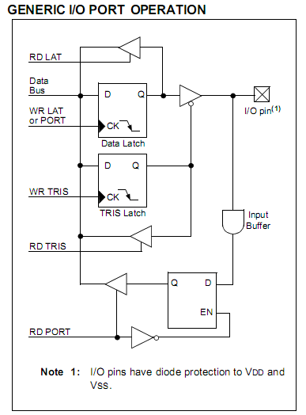
Figure 4.1: I/O PORT OPERATION
Each port has three registers for its operation. These registers are:
•TRIS register (Data Direction register)
•PORT register (reads the levels on the pins of the device)
•LAT registers (Data Latch)

I/O Port Pin Capabilities:
When developing an application, the capabilities of the port pins must be considered. Outputs on some pins have higher output drive strength than others. Similarly, some pins can tolerate higher than VDD input levels.

4.2.2 PIN OUTPUT DRIVE:
The output pin drive strengths vary for groups of pins intended to meet the needs for a variety of applications. PORTB and PORTC are designed to drive higher loads, such as LEDs. All other ports are designed for small loads, typically indication only. Table9-1 sum- marizes the output capabilities.
“Electrical Characteristics” for more details.
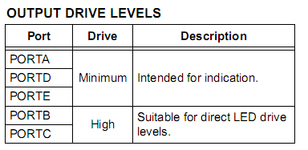
Figure 4.2 Output Drive Values

4.2.3 INPUT PINS AND VOLTAGE CONSIDERATIONS:
The voltage tolerance of pins used as device inputs is dependent on the pin’s input function. Pins that are used as digital only inputs are able to handle DC voltages up to 5.5V; a level typical for digital logic circuits. In contrast, pins that also have analog input functions of any kind can only tolerate voltages up to VDD.

4.2.4 PORTA, TRISA and LATA Registers

PORTA is a 7-bit wide, bidirectional port. It malfunctions as a 5-bit port, depending on the oscillator mode selected. Setting a TRISA bit (= 1) will make the corresponding PORTA pin an input (i.e., put the corresponding output driver in a high-impedance mode). Clearing a TRISA bit (= 0) will make the corresponding PORTA pin an output (i.e., put the contents of the output latch on the selected pin).

The PORTA register reads the status of the pins, whereas writing to it, will write to the port latch. The Data Latch (LATA) register is also memory mapped .Read-modify-write operations on the LATA register read and writes the latched output value for PORTA. The other PORTA pins are multiplexed with analog inputs, the analog VREF+ and VREF- inputs and the comparator voltage reference output. The operation of pins, RA<3:0> and RA5, as A/D converter inputs is selected by clearing or setting the control bits in the ADCON1 register (A/D Control Register 1). Pins, RA0 and RA3, may also be used as comparator inputs and by setting the appropriate bits in the CMCON register. To use RA<3:0> as digital inputs, it is also necessary to turn off the comparators.

All PORTA pins have TTL input levels and full CMOS output drivers. The TRISA register controls the direction of the PORTA pins, even when they are being used as analog inputs. The user must ensure the bits in the TRISA register are maintained set when using them as analog inputs.
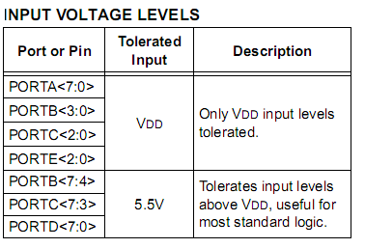
Figure 4.3 Input Voltage Values
4.2.5 PORTB, TRISB and LATB Registers:
PORTB is an 8-bit wide, bidirectional port. The corresponding Data Direction register is TRISB. Setting a TRISB bit (= 1) will make the corresponding PORTB pin an input (i.e., put the corresponding output driver in a high-impedance mode). Clearing a TRISB bit (= 0) will make the corresponding PORTB pin an output (i.e., put the contents of the output latch on the selected pin). The Data Latch register (LATB) is also memory mapped. Read-modify-write operations on the LATB register read and write the latched output value for PORTB. Each of the PORTB pins has a weak internal pull-up.
A single control bit can turn on all the pull-ups. This is performed by clearing bit, RBPU (INTCON2<7>). The weak pull-up is automatically turned off when the port pin is configured as an output. The pull-ups are disabled on a POR. Four of the PORTB pins (RB<7:4>) have an interrupt- on-change feature. Only pins configured as inputs can cause this interrupt to occur
The input pins (of RB<7:4>) are compared with the old value latched on the last read of PORTB. The “mismatch” outputs of RB<7:4> are ORed together to generate the RB Port Change Interrupt with Flag bit, RBIF (INTCON<0>). A mismatch condition continues to set flag bit, RBIF.Reading PORTB will end the mismatch condition and allow flag bit, RBIF, to be cleared after one instruction cycle of delay.
The interrupt-on-change feature is recommended for wake-up on key depression operation and operations where PORTB is only used for the interrupt-on-change feature. Polling of PORTB is not recommended while using the interrupt-on-change feature. The RB5 pin is multiplexed with the Timer0 module clock input and one of the comparator outputs to become the RB5/KBI1/SDI1/SDA1/RP8 pin.
4.2.6 PORTC, TRISC and LATC Registers:
PORTC is an 8-bit wide, bidirectional port. The corresponding Data Direction register is TRISC. Setting a TRISC bit (= 1) will make the corresponding PORTC pin an input (i.e., put the corresponding output driver in a high-impedance mode). Clearing a TRISC bit (= 0) will make the corresponding PORTC pin an output (i.e., put the contents of the output
latch on the selected pin). The Data Latch register (LATC) is also memory mapped. Read-modify-write operations on the LATC register read and write the latched output value for PORTC. PORTC is multiplexed with several peripheral functions. The pins have Schmitt Trigger input buffers.
When enabling peripheral functions, care should be taken in defining TRIS bits for each PORTC pin. Some peripherals override the TRIS bit to make a pin an output, while other peripherals override the TRIS bit to make a pin an input. The user should refer to the corresponding peripheral section for additional information. Unlike other PORTC pins, RC4 and RC5 do not have TRISC bits associated with them. As digital ports, they can only function as digital inputs. If an external transceiver is used, RC4 and RC5 always function as inputs from the transceiver. If the on-chip transceiver is used, the data direction is determined by the operation being performed by the module at that time. The contents of the TRISC register are affected by peripheral overrides. Reading TRISC always returns the current contents, even though a peripheral device may be overriding one or more of the pins.
4.2.7 PORTD, TRISD and LATD Registers:
PORTD is an 8-bit wide, bidirectional port. The corresponding Data Direction register is TRISD. Setting a TRISD bit (= 1) will make the corresponding PORTD pin an input (i.e., put the corresponding output driver in a high-impedance mode). Clearing a TRISD bit (= 0) will make the corresponding PORTD pin an output (i.e., put the contents of the output latch on the selected pin).
The Data Latch register (LATD) is also memory mapped. Read-modify-write operations on the LATD register read and write the latched output value for PORTD. All pins on PORTD are implemented with Schmitt Trigger input buffers. Each pin is individually configurable as an input or output. Each of the PORTD pins has a weak internal pull-up. A single control bit can turn on all the pull-ups. This is per- formed by setting bit, RDPU (PORTE<7>).
The weak pull-up is automatically turned off when the port pin is configured as an output. The pull-ups are disabled on a POR. Note that the pull-ups can be used for any set of features, similar to the pull-ups found on PORTB.
4.2.8 PORTE, TRISE and LATE Registers:
Depending on the particular PIC18F46J11 family device selected, PORTE is implemented in two different ways. For 44-pin devices, PORTE is a 3-bit wide port. Three pins (RE0/AN5/PMRD, RE1/AN6/PMWR and RE2/ AN7/PMCS) are individually configurable as inputs or outputs. These pins have Schmitt Trigger input buffers. When selected as analog inputs, these pins will read as ‘0’s.
The corresponding Data Direction register is TRISE. Setting a TRISE bit (= 1) will make the corresponding PORTE pin an input (i.e., put the corresponding output driver in a high-impedance mode). Clearing a TRISE bit (= 0) will make the corresponding PORTE pin an output (i.e., put the contents of the output latch on the selected pin).
TRISE controls the direction of the RE pins, even when they are being used as analog inputs. The user must make sure to keep the pins configured as inputs when using them as analog inputs.
The Data Latch register (LATE) is also memory mapped. Read-modify-write operations on the LATE register read and write the latched output value for PORTE. Each of the PORTE pins has a weak internal pull-up. A single control bit can turn on all the pull-ups. This is performed by setting bit, REPU (PORTE<6>). The weak pull-up is automatically turned off when the port pin is configured as an output. The pull-ups are disabled on a POR. Note that the pull-ups can be used for any set of features, similar to the pull-ups found on PORTB.
Circumstances that we find ourselves in today in the field of microcontrollers had their beginnings in the development of technology of integrated circuits. This development has made it possible to store hundreds of thousands of transistors into one chip. That was a prerequisite for production of microprocessors, and the first computers were made by adding external peripherals such as memory, input-output lines, timers and other. Further
increasing of the volume of the package resulted in creation of integrated circuits. These integrated circuits contained both processor and peripherals. That is how the first chip containing a microcomputer, or what would later be known as a microcontroller came about.
4.3 Memory unit
Memory is part of the microcontroller whose function is to store data. For a certain input we get the contents of a certain addressed memory location and that's all. Two new concepts are brought to us: addressing and memory location. Memory consists of all memory locations, and addressing is nothing but selecting one of them.
This means that we need to select the desired memory location on one hand, and on the other hand we need to wait for the contents of that location. Besides reading from a memory location, memory must also provide for writing onto it. This is done by supplying an additional line called control line. We will designate this line as R/W (read/write). Control line is used in the following way: if r/w=1, reading is done, and if opposite is true then writing is done on the memory location.
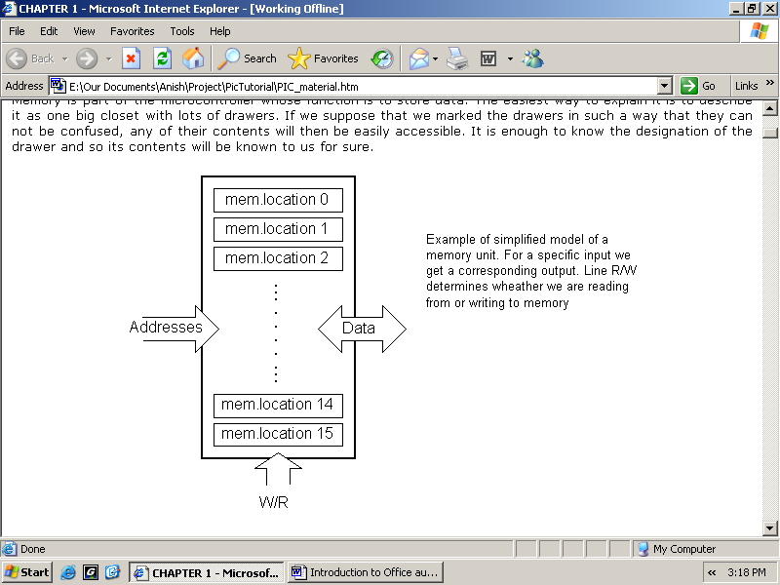
Figure 4.4: Block diagram of memory unit
4.4 Central Processing Unit
Let add 3 more memory locations to a specific block that will have a built in capability to multiply, divide, subtract, and move its contents from one memory location onto another.
The part we just added in is called "central processing unit" (CPU). Its memory locations are called registers.
Registers are therefore memory locations whose role is to help with performing various mathematical operations or any other operations with data wherever data can be found. Look at the current situation. We have two independent entities (memory and CPU) which are interconnected, and thus any exchange of data is hindered, as well as its functionality.
Bus: That "way" is called "bus". Physically, it represents a group of 8, 16, or more wires. There are two types of buses: address and data bus. The first one consists of as many lines as the amount of memory we wish to address and the other one is as wide as data, in our case 8 bits or the connection line. First one serves to transmit address from CPU memory, and the second to connect all blocks inside the microcontroller.
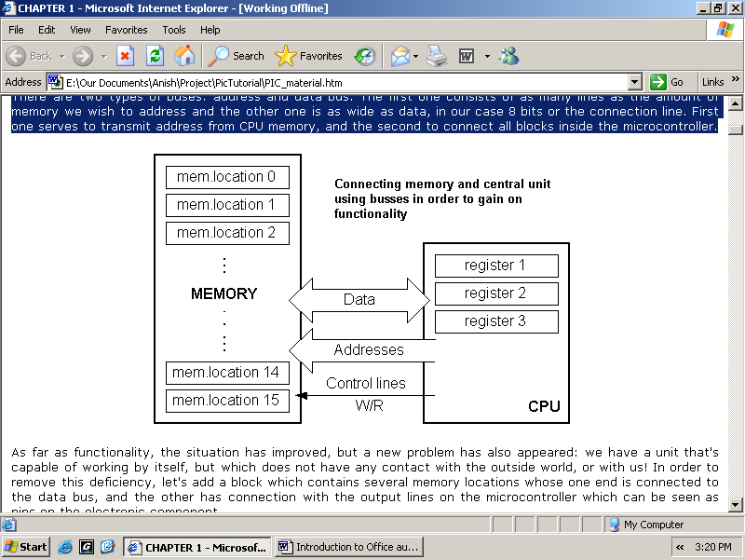
Figure 4.5: Representation of Bus
4.5 Input-output unit
Those locations we've just added are called "ports". There are several types of ports: input, output or bidirectional ports. When working with ports, first of all it is necessary to choose which port we need to work with, and then to send data to, or take it from the port. When working with it the port acts like a memory location. Something is simply being written into or read from it, and it could be noticed on the pins of the microcontroller.
4.6 Serial communication
As we have separate lines for receiving and sending, it is possible to receive and send data (info.) at the same time. So called full-duplex mode block which enables this way of communication is called a serial communication block. Unlike the parallel transmission, data moves here bit by bit, or in a series of bits what defines the term serial communication comes from. After the reception of data we need to read it from the receiving location and store it in memory as opposed to sending where the process is reversed. In order for this to work, we need to set the rules of exchange of data. These rules are called protocol. Data goes from memory through the bus to the sending location, and then to the receiving unit according to the protocol.
4.7 Timer unit
The timer block this can give us information about time, duration, protocol etc. The basic unit of the timer is a free-run counter which is in fact a register whose numeric value increments by one in even intervals, so that by taking its value during periods T1 and T2 and on the basis of their difference we can determine how much time has elapsed. This is a very important part of the microcontroller whose understanding requires most of our time.
Watchdog: One more thing is requiring our attention is a flawless functioning of the microcontroller during its run-time.
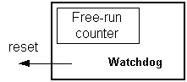
Figure 4.6: Watch dog timer
Suppose that as a result of some interference (which often does occur in industry) our microcontroller stops executing the program, or worse, it starts working incorrectly. Of
course, when this happens with a computer, we simply reset it and it will keep working. However, there is no reset button we can push on the microcontroller and thus solve our
problem. To overcome this obstacle, we need to introduce one more block called watchdog.
This block is in fact another free-run counter where our program needs to write a zero in every time it executes correctly. In case that program gets "stuck", zero will not be written in, and counter alone will reset the microcontroller upon achieving its maximum value. This will result in executing the program again, and correctly this time around.
4.8 Analog to Digital Converter
As the peripheral signals usually are substantially different from the ones that microcontroller can understand (zero and one), they have to be converted into a pattern which can be comprehended by a microcontroller.
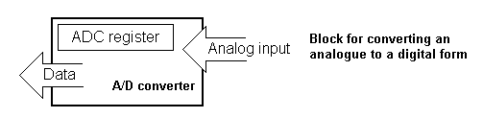
Figure 4.7: Analog to Digital converter
This task is performed by a block for analog to digital conversion or by an ADC. This block is responsible for converting an information about some analog value to a binary number and for follow it through to a CPU block so that CPU block can further process it.
4.9 CISC and RISC
Harvard architecture is a newer concept than Von-Neumann's. It rose out of the need to speed up the work of a microcontroller. In Harvard architecture, data bus and address bus are separate. Thus a greater flow of data is possible through the central processing unit, and of course, a greater speed of work. Separating a program from data memory makes it further possible for instructions not to have to be 8-bit words. It is also typical for Harvard architecture to have fewer instructions than von-Neumann's, and to have
instructions usually executed in one cycle. Microcontrollers with Harvard architecture are also called "RISC microcontrollers".
RISC stands for Reduced Instruction Set Computer. Microcontrollers with von-Neumann's architecture are called 'CISC microcontrollers'
4.10 Memory organization
There are three memory blocks in each of these PICmicro MCUs. The Program Memory and Data Memory have separate buses so that concurrent access can occur.
4.10.1 Program memory organization
The microcontroller devices have a 13-bit program counter capable of addressing an 8K x 14 program memory space. The microcontroller devices have 8K x 14 words of FLASH program memory and the microcontroller UNO devices have 4K x 14. Accessing a location above the physically implemented address will cause a wraparound. The reset vector is at 0000h and the interrupt vector is at 0004h.
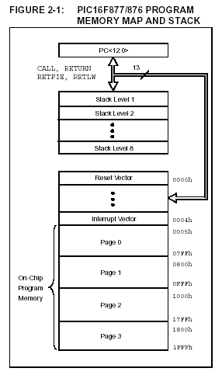
Figure 4.8: Program memory and Stack memory

4.10.2 Data memory organization
The data memory is partitioned into multiple banks which contain the General Purpose Registers and the Special Function Registers. Bits RP1(STATUS<6>) and RP0 (STATUS<5>) are the bank select bits.
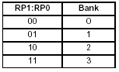
Figure 4.9: Table Register bank selection
Each bank extends up to 7Fh (128 bytes). The lower locations of each bank are reserved for the Special Function Registers. Above the Special Function Registers are General Purpose Registers, implemented as static RAM.
4.10.3 General purpose register file: The register file can be accessed either directly or indirectly through the File Select Register FSR.
4.10.4 Special function registers
The Special Function Registers are registers used by the CPU and peripheral modules for controlling the desired operation of the device. These registers are implemented as static RAM. The Special Function Registers can be classified into two sets; core (CPU) and peripheral.
4.10.5 Status register
The STATUS register contains the arithmetic status of the ALU, the RESET status and the bank select bits for data memory. The STATUS register can be the destination for any instruction, as with any other register. If the STATUS register is the destination for an instruction that affects the Z, DC or C bits, then the write to these three bits is disabled. These bits are set or cleared according to the device logic. The TO and PD bits are not
writable, therefore, the result of an instruction with the STATUS register as destination may be different than intended.
4.11 I²C Protocol
I²C is a multi-master serial computer bus invented by Philips that is used to attach low-speed peripherals to a motherboard, embedded system, or cell phone. The name stands for Inter-Integrated Circuit and is pronounced I-squared-C and also, incorrectly, I-two-C.
I²C uses only two bidirectional open-drain lines, Serial Data (SDA) and Serial Clock (SCL), pulled up with resistors. The I²C reference design has a 7-bit address space with 16 reserved addresses, so a maximum of 112 nodes can communicate on the same bus. The maximum number of nodes is obviously limited by the address space, and also by the total bus capacitance of 400 pF.
To maximize hardware efficiency and circuit simplicity, Philips developed a simple bi-directional 2-wire bus for efficient inter-IC control. This bus is called the Inter IC or I²C -bus. All I²C -bus compatible devices incorporate an on-chip interface which allows them to communicate directly with each other via the I²C -bus. This design concept solves the many interfacing problems encountered when designing digital control circuits. Here are some of the features of the I²C -bus:
- Only two bus lines are required; a serial data line (SDA) and a serial clock line (SCL)
- Each device connected to the bus is software addressable by a unique address and simple master/slave relationships exist at all times; masters can operate as master-transmitters or as master-receivers
- It’s a true multi-master bus including collision detection and arbitration to prevent data corruption if two or more masters simultaneously initiate data transfer
- Serial, 8-bit oriented, bi-directional data transfers can be made at up to 100 kbit/s in the Standard-mode, up to 400 kbit/s in the Fast-mode, or up to 3.4 Mbit/s in the High-speed mode
- On-chip filtering rejects spikes on the bus data line to preserve data integrity
- The number of ICs that can be connected to the same bus is limited only by a maximum bus capacitance of 400 pF.

For 8-bit oriented digital control applications, such as those requiring microcontrollers, certain design criteria can be established:
- A complete system usually consists of at least one microcontroller and other peripheral devices such as memories and I/O expanders
- The cost of connecting the various devices within the system must be minimized
- A system that performs a control function doesn’t require high-speed data transfer
- Overall efficiency depends on the devices chosen and the nature of the interconnecting bus structure.

To produce a system to satisfy these criteria, a serial bus structure is needed. Although serial buses don’t have the throughput capability of parallel buses, they do require less wiring and fewer IC connecting pins. However, a bus is not merely an interconnecting wire, it embodies all the formats and procedures for communication within the system.

Devices communicating with each other on a serial bus must have some form of protocol which avoids all possibilities of confusion, data loss and blockage of information. Fast devices must be able to communicate with slow devices. The system must not be dependent on the devices connected to it, otherwise modifications or improvements would be impossible. A procedure has also to be devised to decide which device will be in control of the bus and when. And, if different devices with different clock speeds are connected to the bus, the bus clock source must be defined. All these criteria are involved in the specification of the I²C -bus.

The I²C bus physically consists of 2 active wires and a ground connection. The active wires, called SDA and SCL, are both bi-directional. SDA is the Serial Data line, and SCL is the Serial Clock line.
Every device hooked up to the bus has its own unique address, no matter whether it is an MCU, LCD driver, memory, or ASIC. Each of these chips can act as a receiver and/or transmitter, depending on the functionality. Obviously, an LCD driver is only a receiver, while a memory or I/O chip can be both transmitter and receiver.
The I²C bus is a multi-master bus. This means that more than one IC capable of initiating a data transfer can be connected to it. The I²C protocol specification states that the IC that initiates a data transfer on the bus is considered the Bus Master. Consequently, at that time, all the other ICs are regarded to be Bus Slaves.

I²C -bus compatible ICs allow a system design to rapidly progress directly from a functional block diagram to a prototype. Moreover, since they ‘clip’ directly onto the I²C -bus without any additional external interfacing, they allow a prototype system to be modified or upgraded simply by ‘clipping’ or ‘unclipping’ ICs to or from the bus. Here are some of the features of I²C -bus compatible ICs which are particularly attractive to designers:
- Functional blocks on the block diagram correspond with the actual ICs; designs proceed rapidly from block diagram to final schematic.
- No need to design bus interfaces because the I²C -bus interface is already integrated on-chip.
- Integrated addressing and data-transfer protocol allow systems to be completely software-defined
- The same IC types can often be used in many different applications
- Design-time reduces as designers quickly become familiar with the frequently used functional blocks represented by I²C -bus compatible ICs
- ICs can be added to or removed from a system without affecting any other circuits on the bus
- Fault diagnosis and debugging are simple; malfunctions can be immediately traced
- Software development time can be reduced by assembling a library of reusable software modules.
The I²C -bus supports any IC fabrication process (NMOS, CMOS, bipolar). Two wires, serial data (SDA) and serial clock (SCL), carry information between the devices connected to the bus. Each device is recognized by a unique address (whether it’s a microcontroller, LCD driver, memory or keyboard interface) and can operate as either a transmitter or receiver, depending on the function of the device. Obviously an LCD driver is only a receiver, whereas a memory can both receive and transmit data. In addition to transmitters and receivers, devices can also be considered as masters or slaves when performing data transfers (see Table 1). A master is the device which initiates a data transfer on the bus and generates the clock signals to permit that transfer. At that time, any device addressed is considered a slave.
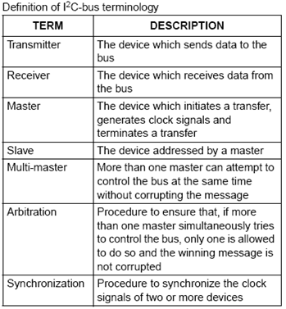
Figure 4.10 I²C-Bus Terminologies

The I²C -bus is a multi-master bus. This means that more than one device capable of controlling the bus can be connected to it. The possibility of connecting more than one microcontroller to the I²C -bus means that more than one master could try to initiate a data transfer at the same time. To avoid the chaos that might ensue from such an event - an arbitration procedure has been developed. This procedure relies on the wired-AND connection of all I²C interfaces to the I²C -bus. If two or more masters try to put information onto the bus, the first to produce a ‘one’ when the other produces a ‘zero’
will lose the arbitration. The clock signals during arbitration are a synchronized combination of the clocks generated by the masters using the wired-AND connection to the SCL line. Generation of clock signals on the I²C -bus is always the responsibility of master devices; each master generates its own clock signals when transferring data on the bus. Bus clock signals from a master can only be altered when they are stretched by a slow-slave device holding-down the clock line, or by another master when arbitration occurs.
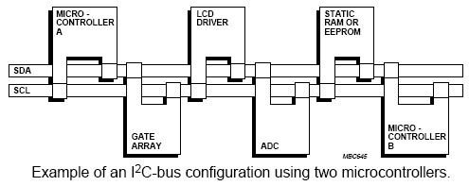
Figure 4.11: I²C Bus Configuration

Both SDA and SCL are bi-directional lines, connected to a positive supply voltage via a current-source or pull-up resistor (see Fig.3). When the bus is free, both lines are HIGH. The output stages of devices connected to the bus must have an open-drain or open-collector to perform the wired-AND function. Data on the I²C -bus can be transferred at rates of up to 100 kbit/s in the Standard-mode, up to 400 kbit/s in the Fast-mode, or up to 3.4 Mbit/s in the High-speed mode. The number of interfaces connected to the bus is solely dependent on the bus capacitance limit of 400 pF.

The MSSP module in I²C mode fully implements all master and slave functions (including general call support) and provides interrupts on Start and Stop bits in hardware to determine a free bus (multi-master function). The MSSP module implements the standard mode specifications, as well as 7-bit and 10-bit addressing.
Two pins are used for data transfer:
• Serial clock (SCL) – RC3/SCK/SCL
• Serial data (SDA) – RC4/SDI/SDA
The user must configure these pins as inputs or outputs through the TRISC<4:3> bits.
REGISTERS
The MSSP module has six registers for I²C operation.
These are:
• MSSP Control Register (SSPCON)
• MSSP Control Register 2 (SSPCON2)
• MSSP Status Register (SSPSTAT)
• Serial Receive/Transmit Buffer Register (SSPBUF)
• MSSP Shift Register (SSPSR) – Not directly accessible
• MSSP Address Register (SSPADD)

SSPCON, SSPCON2 and SSPSTAT are the control and status registers in I²C mode operation. The SSPCON and SSPCON2 registers are readable and writable. The lower six bits of the SSPSTAT are read-only. The upper two bits of the SSPSTAT are read/write. SSPSR is the shift register used for shifting data in or out. SSPBUF is the buffer register to which data bytes are written to or read from. SSPADD register holds the slave device address when the SSP is configured in I²C Slave mode. When the SSP is configured in Master mode, the lower seven bits of SSPADD act as the baud rate generator reload value.

4.12. Display Unit
Cheapest display unit available is LCD. But Pi has an advantage that other display units can be connected to it directly through display port. This display contains two internal byte wise resisters, One for the commands (RS=0) and second for character to be displayed (RS=1). It also contains a user programmed RAM area (the character RAM) that can be programmed to generate any desired character that can form using a dot matrix. To distinguish between these two data areas. The display takes varying amounts of time to accomplish the functions. D4-D7 pin is connected to the D2-D5 Pin of Arduino. RS and EN Pin of display is connected to the D6, D7 Pin Respectively also by giving a proper supply and system ground LCD is ready to display the data.
4.13 GSM modem
GSM is a mobile communication modem. It is widely used for mobile communication system in the world. GSM is an open and digital cellular technology used for transmitting mobile voice and data services operates at the 850MHz, 900MHz, 1800MHz and 1900MHz frequency bands. 2G networks are developed as a replacement for first generation (1G) analog cellular networks, and the GSM standard originally described as a digital, circuit-switched network optimized for full duplex voice telephony. GSM system was developed as a digital system using time division multiple access (TDMA) technique. GSM digitizes and reduces the data, then sends it down through a channel with two different streams of client data, each in its own particular time slot. The digital system has an ability to carry a data rate of 64 kbps to 120 Mbps.
4.14 Power Supply
Power Adaptor 12 Volt 1 Amp Charger AC INPUT 100-240V DC OUTPUT 12V 1A Product Description: Professional 12 Volt DC 1 Amp power supply is suitable for powering a wide range of applications including CCTV cameras and wireless routers. Features: 100% Brand New Excellent Quality Short Circuit, Over Voltage & Over Current Protection. Meet CEC Energy Efficiency Level IV. Incredibly Low Fault Rates No Minimum Load. This power supply is a regulated Center Positive power supply and has a 2.1mm x 5.5mm Jack It's plug design is for Indian power socket. So, no plug converter is required. Compact size & light weight. High Reliability. Regulated Stable Voltage. Good quality SMPS Based Adapter Power LED Monitor (LED Glow when in Use) Stabilized Output, low ripple & low interference Single Output Voltage High Efficiency & low energy consumption Input - 100-240 VAC 50/60hZ Category - Switch Mode Power Adaptor (SMPS) Output Type - DC Output - 12Volts 1Amp PLEASE Applications: Powerful 12v 12w 1A max Current Draw. Replaces lower amped adapters 12v 0.5A 1A. 1.5A etc Smart Replacement Gadget Power Supply for LED, SMD, LED Strip, RGB LED Strip Ideal for Routers / Modems / Mobile Phones / Mp3 players / POS Machines etc. Best for Routers, Wifi Routers security/spy camera receiver and some advanced cameras CCTV , Gadgets , Portable
Players , Set Top Boxes, best for Toys etc., Charging or any gadgets as per the rating of the device , please study and then buy as this
a very technical item only works as per its precise current outputs This power supply is an ideal replacement for a wireless network router such as the Netgear DG834, DG834GT, DG934 etc.. plus a range of many other wireless routers. You will need to check the DC socket size & power rating with the supplier of the router you are using as we cannot confirm it will work.
4.15 GPS Model
It consists of six wires out of which three wires are used for connection. The TX pin of this module which is connected to the D10 pin of the microcontroller. Voltage supply is about 3.3V to 5V.When Push button is pressed, GPS starts receiving signals from 4 satellites out of the 24 satellites in the orbit. Once if the connection is established the latitude and longitude values of the current location are obtained. The GPS acts as a transmitter. The 5V supply is given to the GPS from the controller.
4.16 Push Key
When it is pressed then it will send GPS signal to the controller, then controller will send the GPS co-ordinates via GSM to the pre-defined numbers.
4.17 Heartbeat Sensor
Heart beat sensor is designed to give digital output of heat beat when a finger is placed inside it. This digital output can be connected to Arduino directly to measure the Beats per Minute (BPM) rate. It works on the principle of light modulation by blood flow through finger each pulse. IC LM358 is used for this sensor. Its dual low power operational amplifier consists of a super bright red LED and light detector. One will act as amplifiers and another will be used as comparator. LED needs to be super bright as the light must pass through finger and detected at other end. When heart pumps a pulse of blood through blood vessels, finger becomes slightly more opaque so less light reach at the detector. With each heart pulse, the detector signal varies which is converted to electrical pulse.
4.18 MEMS Detector
- Plug the sensor into one of the RJ45 ports on the rear panel of the unit.

- Now point your browser to the IP address of the unit (default, 192.168.0.100). Next you need to login as the administrator using your administrator password (default is “public”). You will then be taken to the summary page.

- From the summary page you need to select the sensors tab. The layout of the next page will vary depending on your unit so please refer to your units manual.

- You should now be able to setup the thresholds for your sensor. The low critical, low warnings, normal, high warnings, high critical values can be set from this page.

Now we will cover the settings that are specific to your sensor.

Port: Displays the port description

Description: This should be changed to give a meaningful description of what the port is sensing. Example, "Currently sensing server room", "Wiring closet". This description will be displayed under the motion detection sensor page.

Current Reading: Displays the current sound level.

Status: The status displays the current state of the sound sensor. The status can be No Status (if the sensor is offline), or display a user-defined description when the sensor is normal or critical.

Sensor Online/Offline: Indicates whether the sensor is either online or offline. If the sensor is offline then the status will not be updated if changed.

Go Online/Offline Use this checkbox to put the motion sensor online or offline (i.e.
connected or disconnected). Note that selecting offline will effectively disconnect the sensor, and its status will read "No Status" and Offline.

Microphone Sensitivity: The level of sensitivity that can be set. For example, if you set the level to 80, then the microphone will detect more sound if the level was set a 20.

Pulse Length: This defines the minimum duration of a sound to trigger an alert notification.

Critical and Warning levels: These can be set individually based on the working environment. An alert notification will be sent if the sound level reaches one of these levels.

CHAPTER 5
SOFTWARE DESCRIPTION

5.1 INTRODUCTION
USE OF OPEN SOURCE TECHNOLOGY
Open of the fundamental factors driving the adoption of Linux is the fact that it is open source. Generally open source refers to a program in which the source code is available to the general public for use and or modification from its original design free of charge, reopen. Open source code typically created as a collaborative effort in which programmers improve upon the code and share the changes within the community. The Linux kernel is licensed under term of the GNU GPL. The second paragraph of the GNU GPL declares:” when we speak about of free software, we are referring to freedom, not price,” one can download the Linux kernel for free and install it. For being open source the software as well as the tools are reliable flexible, have a huge community support and finally they are free to use which play a major role in reducing the overall development cost.
Operation System
An operating system is a program designed to run other programs on a computer. A computer operating system is its most important program. It is considered the backbone of a computer like managing both software and hardware resources. Operating system are responsible for everything from the control and allocation of memory to recognizing input from external devices and transmitting output to the computer display. They also manage files on computer hard drives and control peripherals like camera, printers CPU etc. The operating system makes sure everything runs smoothly, without interference, despite the fact that numerous devices and programs are used simultaneously. An
operating system also has a vital role to play in security. Its job include preventing unauthorized users from accessing the computer system.
What is C?
C is general purpose, block structured, procedural, impressive computer programming language developed in 1972 by Dennis Ritchie at the Bell telephone Laboratories for use with the UNIX operating system.
Why C?
C has proved to be a powerful and flexible language that can be used for a variety of applications, from business programs to engineering. C is a particularly popular language for personal computer programmers because it is relative small its requires less memory than other languages. Although it is a high level language, c is much closer to assembly language than are most other high-level languages. This closeness to the underlying machine language allows C programmers to write very efficient code.
HTML
Hypertext mark-up language is used for the the web document and it’s also stand for hypertext. HTML documents are described by html tags and each tags describe different document content. The mark-up tells the web browser how to display a web pages words and images for the user.
Why HTML
To show the online output. HTML is a computer language devised to allow web sites creation. This web sites can then be viewed by any one else connected to the internet. It is relatively easy to learn , with the basic being accessible to most people in one sitting , and quite powerful in what is allow to create.
The software tools which are used for the implementation are listed below, they are
- MPLAB IDE
- C18 COMPILER

5.2 MPLAB IDE
MPLAB integrated development environment is a comprehensive editor, project manager and design desktop for application of development of embedded design using Microchip ARDUINO MCU and ARDUINO DSC.
MPLAB is a window operating system software program that runs on a PC to develop application for microchip microcontroller and digital signal controller. It is called an integrated development environment or IDE, it provides a single integrated environment to develop code for embedded microcontroller.
Embedded C language is used in MPLAB IDE. Embedded C is a set of language extensions for the C programming language by the C standard committee to address commonality issues that exist between C extensions for different embedded system. Historically, embedded C programming requires nonstandard extensions to the C language in order to support exotic features such as fixed-point arithmetic, multiple distinct memory banks, and basic I/O operations.
- Code speed is governed by the processing power, timing constraints
- Code size is governed by available program memory and use of programming language.
The Embedded software is associated with each processor which acts as a brain in each embedded systems. If hardware forms the body of an embedded system, embedded processor acts as the brain, and embedded software forms its soul. It is the embedded software which primarily governs the functioning of embedded systems. Goal of embedded software programming is to get maximum features in minimum space and minimum time. Embedded software needs to include all needed device drivers at manufacturing time and the device drivers are written for the specific hardware.

5.3 C18 COMPILER
The MPLAB C18 compiler is a free-standing, optimizing ANSI C compiler for the ARDUINO microcontroller unit. The compiler deviates from the ANSI standard X3.159-1989 only where the standard conflicts with efficient ARDUINO micro MCU support. The compiler is a 32-bit Windows console application and is fully compatible with Microchip’s MPLAB IDE, allowing secure level debugging with the MPLAB ICE in circuit emulator, the MPLAB ICD 2 in circuit debugger or the MPLAB SIM simulator.
MPLAB C18 has the following features:
- ANSI ‘89 compatibility.
- Integration with the MPLAB IDE for easy-to-use project management and source level debugging.
- Generation of re-alocatable object modules for enhanced code reuse.
- Compatibility with object modules generated by the MPASM assembler, allowing complete freedom in mixing assembly and C programming in a single project.
- Transparent read/write access to external memory.
- Strong support for inline assembly when total control is absolutely necessary.
- Efficient code generator engine with multilevel optimization.
- Extensive library support including PWM, SPITM, I²C TM, UART, USART, string manipulation and math libraries.

CHAPTER 6
CONCLUSION AND FUTURE WORK

Overall, this system proved successful whilst testing.
With the use of multi sensor networks transferring
multiple data to a central hub which is then organized and
displayed using a web application which also consists of a
real time graph plot proves to be a handy monitoring
system for ships. This system somewhat eradicates the
problem of proper alarm and notification.
Overall, this system proved successful whilst testing.
With the use of multi sensor networks transferring
multiple data to a central hub which is then organized and
displayed using a web application which also consists of a
real time graph plot proves to be a handy monitoring
system for ships. This system somewhat eradicates the
problem of proper alarm and notification.
Overall, this system proved successful whilst testing.
With the use of multi sensor networks transferring
multiple data to a central hub which is then organized and
displayed using a web application which also consists of a
real time graph plot proves to be a handy monitoring
system for ships. This system somewhat eradicates the
problem of proper alarm and notification.
The proposed design will deal with critical issues faced by women and will help to solve them with technologically sound equipment and ideas. The merit of this work is it not only provides safety and it also provides security by means of self-defense mechanism. The crime against the women can be now brought to an end with the help of real system implementation of the proposed model.
The proposed AI-driven wearable safety system provides an intelligent and reliable solution for personal security and emergency monitoring. The system successfully integrates heartbeat sensing, MEMS motion detection, Bluetooth Low Energy communication, and ibeacon technology to continuously monitor the user’s physiological condition and movement patterns in real time. By analyzing abnormal conditions such as sudden stress responses, unusual body movements, or emergency situations, the device can automatically activate a silent rescue mode and transmit distress signals to authorized receivers.
One of the major advantages of the system is its ability to function effectively in both indoor and outdoor environments, including GPS-denied areas such as vehicles, containers, underground spaces, and enclosed environments where traditional tracking systems are unreliable. The use of low-power BLE communication makes the system energy-efficient, cost-effective, portable, and independent of continuous internet connectivity or smartphones.
The project demonstrates how wearable technology, embedded systems, and intelligent monitoring techniques can improve personal safety and emergency response mechanisms. Overall, the system offers a smart, secure, and practical safety solution for real-time monitoring and rapid assistance during dangerous situations.

REFERENCES

1. Dr. AntoBennet, M, SankarBabu G, Natarajan S, “Reverse Room Techniques for Irreversible Data Hiding”, Journal of Chemical and Pharmaceutical Sciences 08(03): 469-475, September 2025.
2. Dr. AntoBennet, M ,Sankaranarayanan S, SankarBabu G, “ Performance & Analysis of Effective Iris Recognition System Using Independent Component Analysis”, Journal of Chemical and Pharmaceutical Sciences 08(03): 571-576, August 2025.
3. Dr. AntoBennet, M, Suresh R, Mohamed Sulaiman S, “Performance &analysis of automated removal of head movement artifacts in EEG using brain computer interface”, Journal of Chemical and Pharmaceutical Research 07(08): 291-299, August 2025.
4. Dr. AntoBennet, M “A Novel Effective Refined Histogram For Supervised Texure Classification”, International Journal of Computer & Modern Technology , Issue 01 ,Volume02 ,pp 67-73, June 2025.
5. Dr. AntoBennet, M, SrinathR,RaishaBanuA,“Development of Deblocking Architectures for block artifact reduction in videos”, International Journal of Applied Engineering Research,Volume 10, Number 09 (2025) pp. 6985-6991, April 2025.
6. AntoBennet, M &JacobRaglend, “Performance Analysis Of Filtering Schedule Using Deblocking Filter For The Reduction Of Block Artifacts From MPEQ Compressed Document Images”, Journal of Computer Science, vol. 8, no. 9, pp. 1447-1454, 2022.
7. AntoBennet, M &JacobRaglend, “Performance Analysis of Block Artifact Reduction Scheme Using Pseudo Random Noise Mask Filtering”, European Journal of Scientific Research, vol. 66 no.1, pp.120-129, 2021.
8. A.H.Ansari, BalsarfPratiksha P, MaghadeTejal R, YelmameSnehal M, “Women Security System using GSM & GPS”, International Journal of Innovative Research in Science, Engineering and Technology”, Vol.6, Issue 3, March 2023.
9. Azhaguramyaa V R, Sangamithra D, Sindhja B, “RFID Based Security System for Women”, International Journal of Scientific & Engineering Research Volume 8 Issue 5, May-2022.
10. TruptiRajendraShimpi, “Tracking and Security System for Women’s using GPS & GSM, International Research Journal of Engineering and Technology (IRJET), Volume: 04 Issue:07 | July-2021.
11. S. Vahini, N. Vijaykumar, “Efficient tracking for women safety and security using IoT”, International Journal of Advanced Research in Computer Science, Volume 8, No,.9, November-December 2021.
12. D.G. Monisha, M. Monisha, G. Pavithra and R. Subhashini, “Women Safety Device and Application-FEMME”, Indian Journal of Science and Technology, Vol9 (10), March 2022.
13. GeethaPratyushaMiriyala, P.V.V.N.D.P Sunil, RamyaSreeYadlapalli, Vasantha Rama Lakshmi Pasam, TejawiKondapalli, AnushaMiriyala, “Smart Intelligent Security System for Women”, International Journal of Electronics and Communication Engineering & Technology (IJECET), Volume 7, Issue 2, March-April 2016.
14. RashaTalal Hammed, Omar AbdulwahabeMohamad, NicolaeTapus, “Health Monitoring System Based on Wearable Sensors and Cloud Platform”, 20th International Conference on System Theory, Control and Computing (ICTSCC), 2026.
15. AbhijitParadkar, Deepak Sharma, “All in one Intelligent Safety System for Women Security”, International Journal of Computer Applications (0975-8887) Volume 130- No.11, November 2025.

APPENDIX 1
PROGRAM CODING
#include <SoftwareSerial.h>
#include <stdlib.h>
#include <TinyGPS.h>
#include<Wire.h>
#include<LiquidCrystal_I2C.h>
LiquidCrystal_I2C lcd(0x27,16,2);
TinyGPS gps;
float flat,flon;
int count=0,i=0,k=0,rate=0;
unsigned long time2,time1;
#define DEBUG true
SoftwareSerial esp8266(2,3); // make RX Arduino line is pin 2, make TX Arduino line is pin 3.
SoftwareSerial myserial(9,10); // make RX Arduino line is pin 2, make TX Arduino line is pin 3.
void setup()
{
lcd.backlight();
lcd.init(); // initialize the lcd
lcd.begin(16,2);
lcd.setCursor(0,0);
lcd.print("WOMEN SAFETY");
pinMode(7,INPUT);
Serial.begin(9600);
myserial.begin(9600);
esp8266.begin(115200); // your esp's baud rate might be different
sendData("AT+RST\r\n",2000,DEBUG); // reset module
Serial.println("Resetting");
delay(3000);
sendData("AT+CWMODE=1\r\n",1000,DEBUG); // configure as access point
sendData("AT+CIFSR\r\n",1000,DEBUG); // get ip address
sendData("AT+CIPMUX=1\r\n",1000,DEBUG); // configure for multiple connections
sendData("AT+CIPSERVER=1,80\r\n",1000,DEBUG); // turn on server on port 80
}
static void smartdelay(unsigned long ms)
{
unsigned long start = millis();
do
{
//Serial.print("check");
while (Serial.available())
gps.encode(Serial.read());
} while (millis() - start < ms);
}
void loop()
{
if(esp8266.available()) // check if the esp is sending a message
{
Serial.print("pin_number1:");
if(esp8266.find("+IPD,"))
{
Serial.print("pin_number2:");
delay(10000);
delay(10000); // wait for the serial buffer to fill up (read all the serial data)
// get the connection id so that we can then disconnect
int connectionId = esp8266.read()-48; // subtract 48 because the read() function returns
// the ASCII decimal value and 0 (the first decimal number) starts at 48
/*---------------------------------------------------------*/
int pin_number = 0;
if(esp8266.find("pin=")) // advance cursor to "pin="
{
pin_number = esp8266.parseInt();
Serial.print("pin_number3:");
Serial.print(pin_number);
delay(10000);
if((pin_number == 1))
{
digitalWrite(4,HIGH);
digitalWrite(5,HIGH);
digitalWrite(6,HIGH);
}
else if((pin_number == 0))
{
digitalWrite(4,LOW);
digitalWrite(5,LOW);
digitalWrite(6,LOW);
}
}
String webpage;
String cipSend;
webpage = "<head><title>Women_Safety</title></head>";
webpage+= "<h1 align=center><font color=\"red\">ALARM<font color=\"blue\">SWITCH</font></h1>"; //<font color=\"black\"> Survelliance
webpage+="<br/>";
webpage+="<br/>";
webpage+="<body bgcolor=\"#FFF6FA\" align=center>SWITCH<button onclick=\"location.href='/pin=1'\">ON</button></t><button onclick=\"location.href='/pin=0'\">OFF</button><br/>";
//webpage+="<br/>";
//webpage+= "<META HTTP-EQUIV=\"refresh\" CONTENT=\"10\">";
webpage+= "</body>";
cipSend = "AT+CIPSEND=";
cipSend += connectionId;
cipSend += ",";
cipSend +=webpage.length();
cipSend +="\r\n";
sendData(cipSend,1000,DEBUG);
sendData(webpage,1000,DEBUG);
String closeCommand = "AT+CIPCLOSE=";
closeCommand+=connectionId; // append connection id
closeCommand+="\r\n";
sendData(closeCommand,1000,DEBUG); // close connection
}
}

smartdelay(1000);
gps.f_get_position(&flat, &flon);
String latitude = String(flat,6);
String longitude = String(flon,6);
Serial.println(latitude+";"+longitude);
delay(1000);
unsigned int heart,pres;
static double oldValue = 0;
static double oldChange = 0;
k=0;
rate=0;
while(k<6)
{
if(digitalRead(7))
{
if(k==0)
time1=millis();
k++;
while(digitalRead(7));
}
}
time2=millis();
rate=time2-time1;
rate=rate/6;
rate=60000/rate;

// Read the value from Sensors
// Read 10 values for averaging.
/*--------------------------------------------------------*/
// heart = analogRead(1);
heart = rate;
heart = heart/3;
Serial.print(heart);
delay(2);
int x_axis = analogRead(1);
delay(2);
pres=analogRead(0);
delay(2);
Serial.print("s:");
Serial.print(pres);
lcd.setCursor(0,1);
lcd.print("HB:");
lcd.setCursor(10,1);
lcd.print("x:");
lcd.setCursor(3,1);
//lcd.print(heart);
delay(500);
lcd.print(" ");
lcd.setCursor(12,1);
lcd.print(x_axis);
lcd.print(" ");
if (heart > 200)
{
String msg = "";
Serial.println("Check2 ");
msg +="person under danger:";
msg += String(flat);
msg += ',';
msg += String(flon);
send_sms(msg);
delay(2000);
}
else if (pres > 1000)
{
String msg = "";
Serial.println("Check2 ");
msg +="person under danger:";
msg += String(flat);
msg += ',';
msg += String(flon);
send_sms(msg);
delay(2000);
}
else if( x_axis < 300)
{
while (count < 3){
String msg = "";
Serial.println("Check2 ");
msg +="person under danger:";
msg += String(flat);
msg += ',';
msg += String(flon);
send_sms(msg);
delay(2000);
count++;
}
}
delay(10);
}
void send_sms(String s){
Serial.println("sms function");
myserial.println("AT+CMGF=1"); //Sets the GSM Module in Text Mode
delay(1000); // Delay of 1000 milli seconds or 1 second
myserial.println("AT+CMGS=\"+917200616540\"\r"); // Replace x with mobile number
delay(1000);
myserial.println(s);// The SMS text you want to send
delay(100);
myserial.println((char)26);// ASCII code of CTRL+Z
delay(100);
}
String sendData(String command, const int timeout, boolean debug)
{
String response = "";
esp8266.print(command); // send the read character to the esp8266
long int time = millis();
while( (time+timeout) > millis())
{
while(esp8266.available())
{
// The esp has data so display its output to the serial window
char c = esp8266.read(); // read the next character.
response+=c;
}
}
if(debug)
{
Serial.print(response);
}
return response;
}

APPENDIX 3
OUTPUT SCREENSHOT

